White stuff

White light contains all the colours of the spectrum.
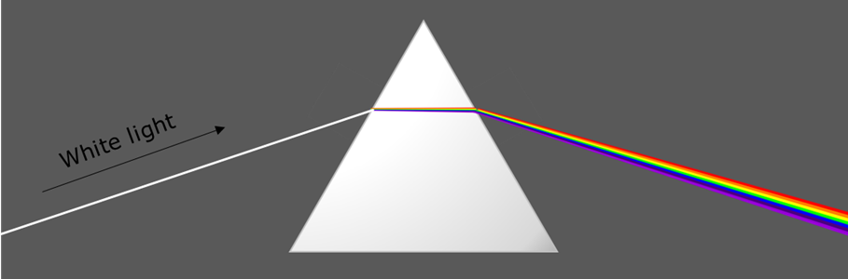

In white light, white objects look white.


Why do white objects look white in white light?
Which of these statements do you think are right?
For each statement, tick (✓) one column to show what you think.
Statements |  | I am sure this is right | I think this is right | I think this is wrong | I am sure this is wrong
A | They reflect all the colours of the spectrum
B | They reflect no colours of light
C | White objects always look white

Physics > Big idea PSL: Sound, light and waves > Topic PSL2: How we see > Key concept PSL2.2: Seeing in colour
Diagnostic question
White stuff

Overview
Learning focus: | Light has colours that are seen when reflected by bodies.
Observable learning outcome: | Describe how white objects reflect all the colours in white light.
Question type: | Confidence grid
Key words: | White light, reflect

What does the research say?
To understand why objects look the colour they do students need first to understand the scientific explanation of how we see non-luminous objects. Students’ development of these ideas are illustrated below and are considered in the key concept: PSL2.1 The ‘passive eye model’ of vision.
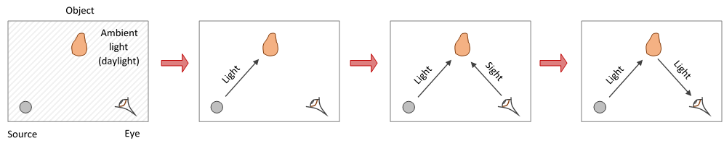
The progression in conceptions of vision encountered among 13- to 14-year-olds, towards that of a physicist (Guesne, 1985)
In a study of 13-year-olds (n=150), 72% did not think that white light was a mixture of different colours (Zylbersztajn and Watts, 1982; Driver et al., 1994). For a physicist, sunlight and daylight are both examples of white light. Each consists of all the colours of the spectrum which combine to be seen as white. Students often regard white light as ‘pure light’ that is free of any tinge. More than half of a sample of 13- to 16-year-olds (n=166) considered colour to be different to light and something that is added to light (Galili and Hazan, 2000). This idea was covered earlier in this key concept, in the progression toolkit: White light.
This question investigates whether students are correctly combining both of these ideas in order to understand that objects are seen as white because they reflect all the colours of the spectrum.
Ways to use this question
Students should complete the confidence grid individually. This could be a pencil and paper exercise, or you could use an electronic ‘voting system’ or mini white boards and the PowerPoint presentation.
If there is a range of answers, you may choose to respond through structured class discussion. Ask one student to explain why they gave the answer they did; ask another student to explain why they agree with them; ask another to explain why they disagree, and so on. This sort of discussion gives students the opportunity to explore their thinking and for you to really understand their learning needs.
Differentiation
You may choose to read the questions to the class, so that everyone can focus on the science. In some situations it may be more appropriate for a teaching assistant to read for one or two students.
Expected answers
A – ‘They reflect all the colours of the spectrum’ is correct
Statements B and C are wrong
How to respond - what next?
An object is seen as white when all the colours of the spectrum reflect off it into the eye. These colours combine to make white.
Answer B may be given by students who perceive white to be a pure colour with no added tinge. They may consider light to be reflected, but no colour.
Answer C may be given by students who think that the colour of an object is a property of the object that is independent from the light falling on it. About 8% of secondary students hold this view (Martinez-Borreguero et al., 2013).
If students have misunderstandings about why white objects look white in white light, it may be necessary to revisit ideas about white light earlier in this key concept, or ideas about how non-luminous objects are seen in the key concept: PSL2.1 The ‘passive eye model’ of vision. Following a discussion about the scientific explanation, students could be given the opportunity to write what is happening in their own terms, or to illustrate it with a labelled diagram.
The following BEST ‘response activity’ could also be used in follow-up to this diagnostic question:
- Response activity: Red fridge light
Acknowledgments
Developed by Peter Fairhurst (UYSEG).
Images: Peter Fairhurst (UYSEG).
References
Driver, R., et al. (1994). Making Sense of Secondary Science: Research into Children's Ideas, London, UK: Routledge.
Galili, I. and Hazan, A. (2000). Learners' knowledge in optics: interpretation, structure and analysis. International Journal of Science Education, 22(1), 57-88.
Guesne, E. (1985). Light. In Driver, R., Guesne, E. & Tiberghien, A. (eds.) Children's Ideas in Science. Milton Keynes: Open University Press.
Martinez-Borreguero, G., et al. (2013). Detection of Misconceptions about Colour and an Experimentally Tested Proposal to Combat them. International Journal of Science Education, 35:8, 1299-1324.
Zylbersztajn, A. and Watts, D. M. (1982). Throwing some light onto colour. Guildford: Mimeograph, University of Surrey.

